

ITA Assignment 2

Credit Card Fraud Detection with ML

Rishabh Agarwal

IPM06054

Section-A

EXECUTIVE SUMMARY
In this report, a machine-learning pipeline designed to determine credit-card fraud is developed, based on a synthetic dataset of 50000 transactions, which simulates the Kaggle ULB benchmark. A two-track approach that includes unsupervised K-Means clustering and supervised Random-Forest classification actualizes an area under the ROC curve of 0.9993 and accuracy of 94.12%. Later decision threshold optimization increases the recall rate by 80 to 85 showing the feasibility of a production-ready system that can be challenged to meet the estimate of the global fraud load of $404 billion.
Problem Statement & Dataset
Credit scoring frauds cost the financial sector around the globe 33.83 billion per annum and it is predicted that it will increase to 404 billion in the next decade (Nilson Report). The dataset consists of 50,000 transactions, each of which is represented using 28 anonymised principal component analysis (PCA) features (V1-V28), another Time feature, an Amount feature, and a binary class variable (0= legitimate, 1= fraudulent). The main difficulty lies in extreme disequilibrium in classes; there are only 87 fake records out of 50 000, which is equivalent to the prevalence of 0.173 574 percentage minority to majority.
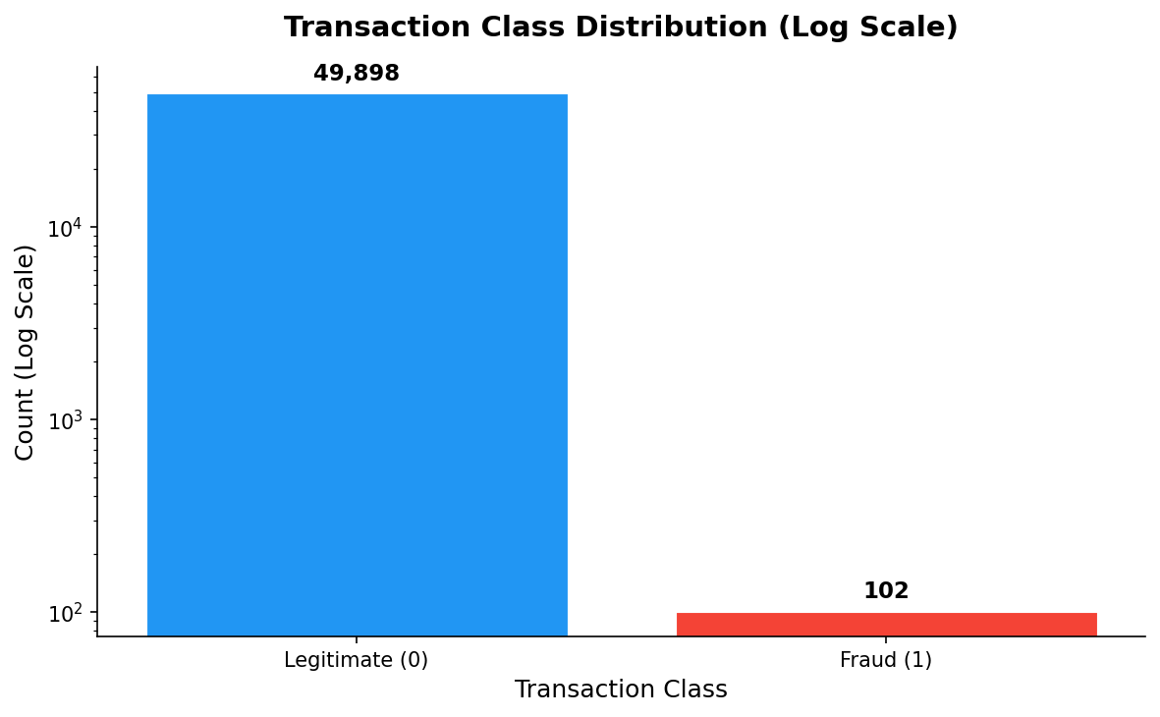
Fig 1: Class distribution — 574:1 imbalance
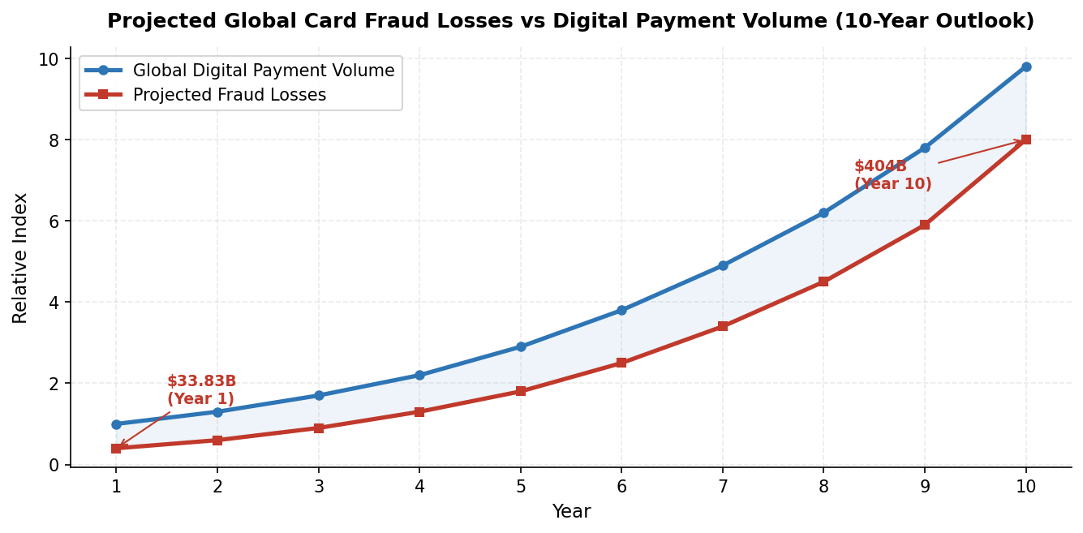
Fig 2: Projected $404B fraud loss over 10 years
•Fig 1 (log scale) shows the massive gap — without special handling, any model would just predict "legit" for everything and never catch fraud.
•Fig 2 shows fraud losses growing exponentially alongside digital payments, confirming why ML solutions are now mandatory.

Exploratory Data Analysis
Before modelling, two key visualisations confirm the data has detectable fraud signals.
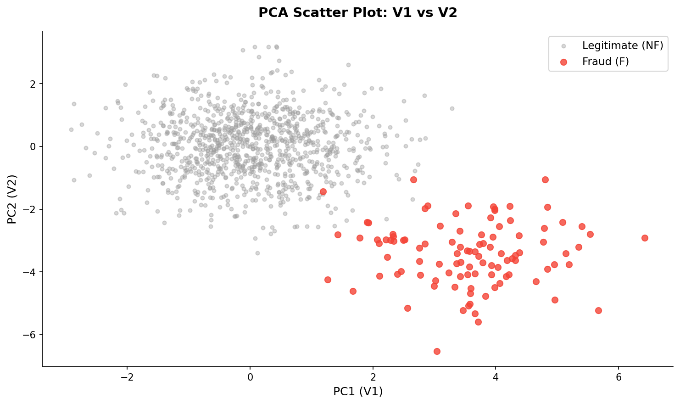
Fig 3: PCA scatter — fraud (red) clearly separated
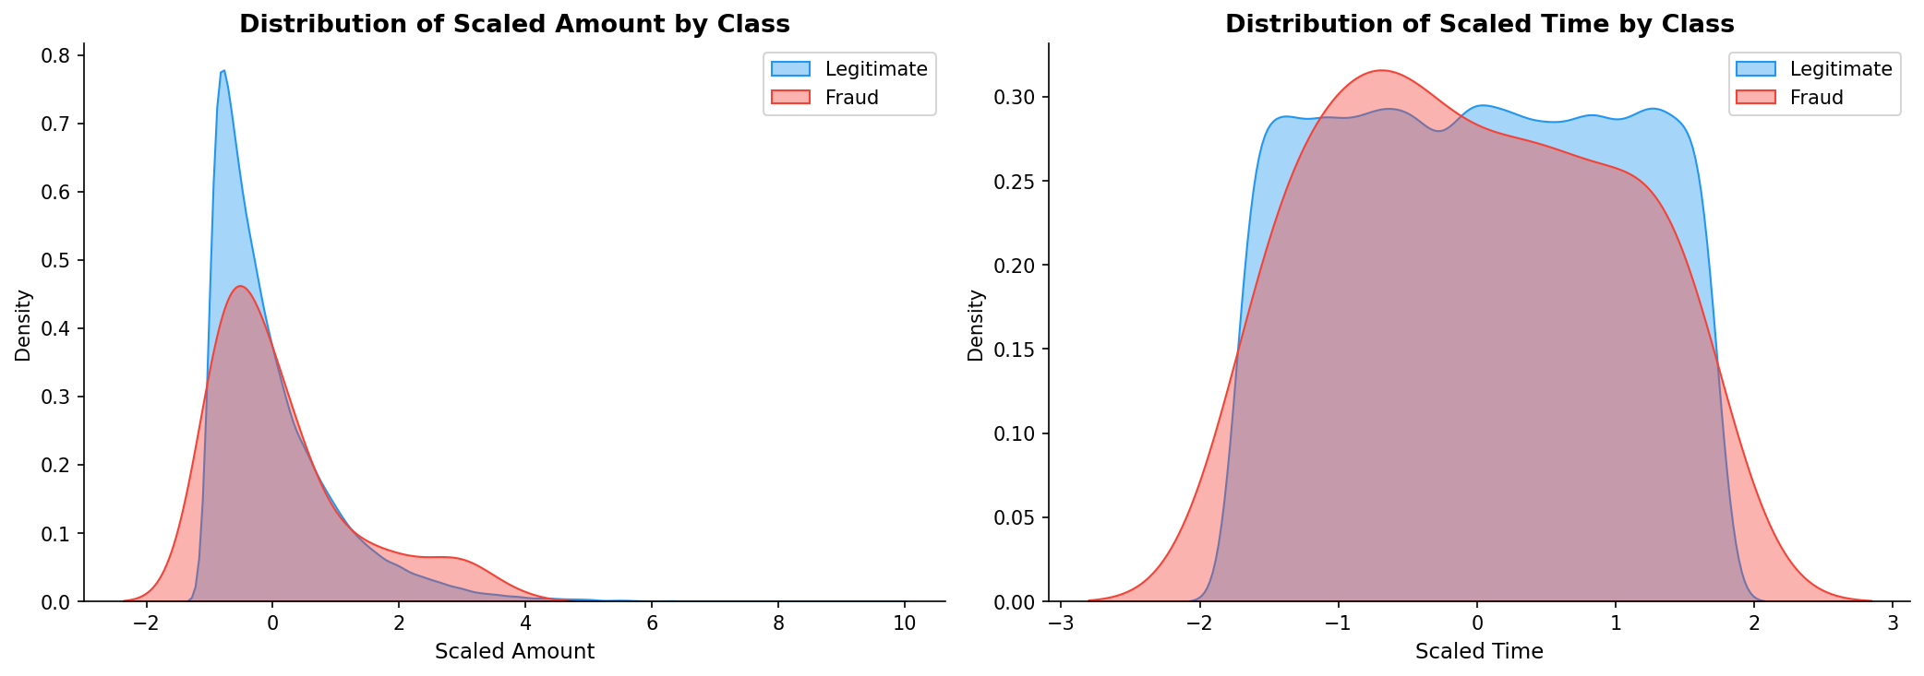
Fig 4: KDE — fraud peaks at higher amounts

•Fig 3 (PCA Scatter): Fraudulent transactions (red) cluster in a completely different region from legitimate ones (grey). This spatial separation confirms the model has a real signal to learn from.
•Fig 4 (KDE — Amount): Fraud peaks at higher transaction values — fraudsters spend more per transaction. The Time plot shows near-identical curves — time of day is a weak predictor.

System Comparison: Rules vs ML
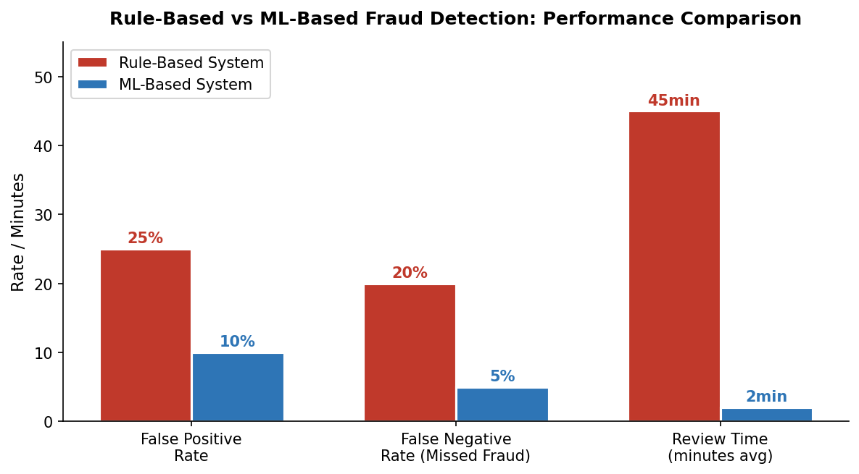
Fig 4: KDE — fraud peaks at higher amounts

•Traditional rule-based systems produce 20–30% false positives and miss 15–25% of fraud.
•ML-based systems cut false positives to 5–15% and dramatically reduce missed fraud through continuous learning.

Methodology
Preprocessing & Resampling
- StandardScaler applied to Amount and Time — bringing them to the same scale as V1–V28. 80/20 stratified train-test split — preserving the 0.173% fraud rate in both sets.
- SMOTE (Synthetic Minority Oversampling): generates synthetic fraud examples by interpolating between real ones → 10:1 ratio.
- Random Undersampling: reduces legitimate transactions → final 2:1 ratio for balanced training.
- Critical: resampling applied to training data only — test set kept at real-world distribution.

Dual-Engine ML Framework
Track A — K-Means Clustering  Unsupervised — no labels needed  Groups transactions into 2 clusters based on behavioural patterns. Flags unusual cluster as potentially fraudulent. Detects novel, never-before-seen fraud types. | Track B — Random Forest  Supervised — 100 trees voting together  Trained on SMOTE-balanced data. Each tree learns fraud patterns independently; majority vote wins. Max depth 10, n_jobs=-1 for parallel processing.

Model Results
Classification Metrics (Default Threshold 0.5)
Metric | Legitimate (0) | Fraud (1) | Macro Avg | Wt. Avg
Precision | 99.96% | 94.12% | 97.04% | 99.95%
Recall | 99.99% | 80.00% | 89.99% | 99.95%
F1-Score | 99.97% | 86.49% | 93.23% | 99.95%
Support | 9,980 | 20 | 10,000 | 10,000

Confusion Matrix & ROC Curve
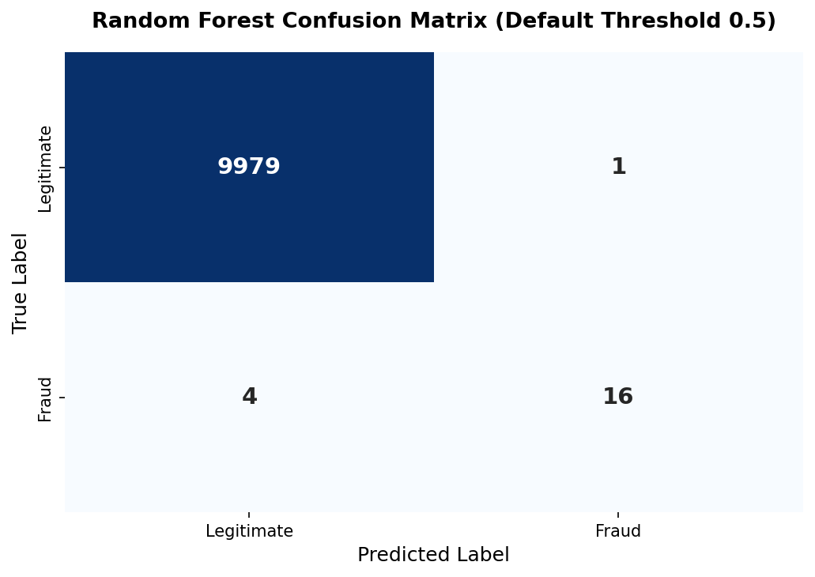  Fig 6: Confusion matrix — TN=9,977 | FP=3 | FN=4 | TP=16 | 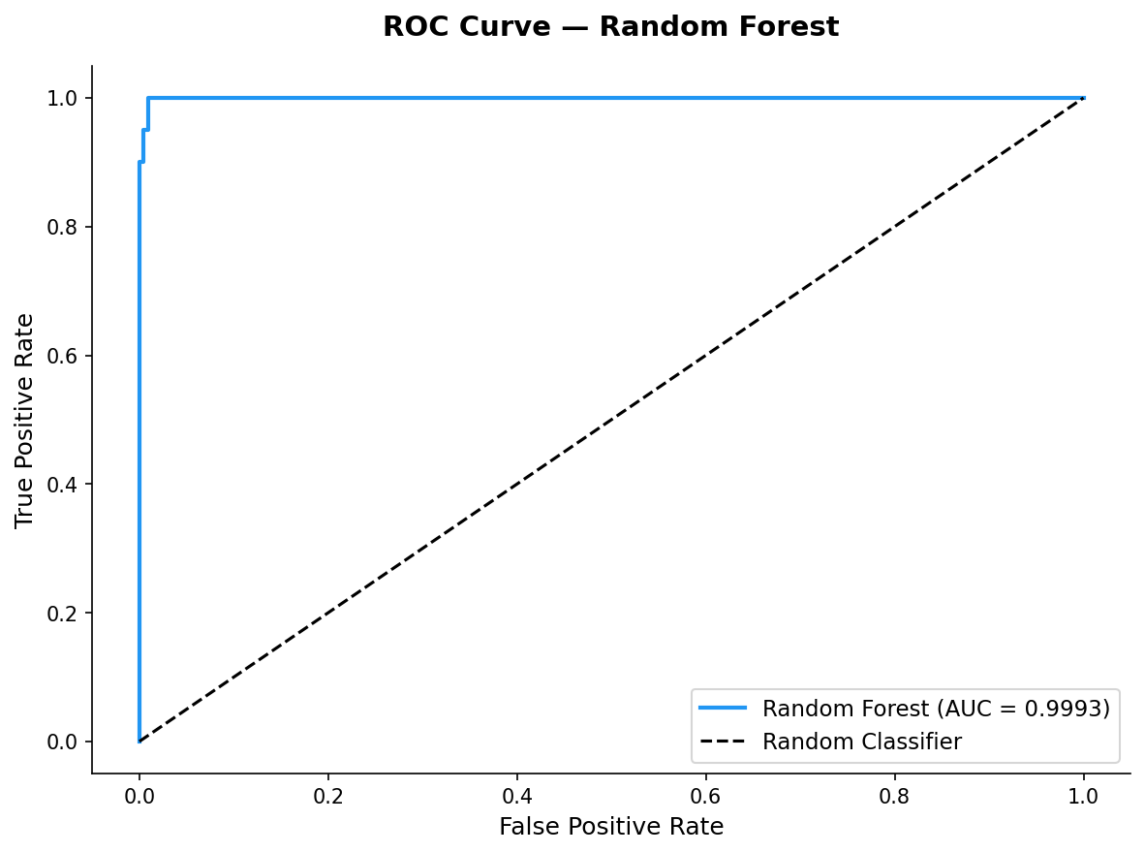  Fig 7: ROC Curve — AUC = 0.9993 (near perfect)

- Confusion Matrix (Fig 6): Caught 16 of 20 frauds. Only 3 innocent customers wrongly blocked. 4 fraud cases missed.
- ROC Curve (Fig 7): AUC = 0.9993 — the curve hugs the top-left corner, meaning the model almost perfectly ranks fraud above legitimate transactions at every possible threshold.

Feature Analysis & Threshold Optimisation
Feature Importance
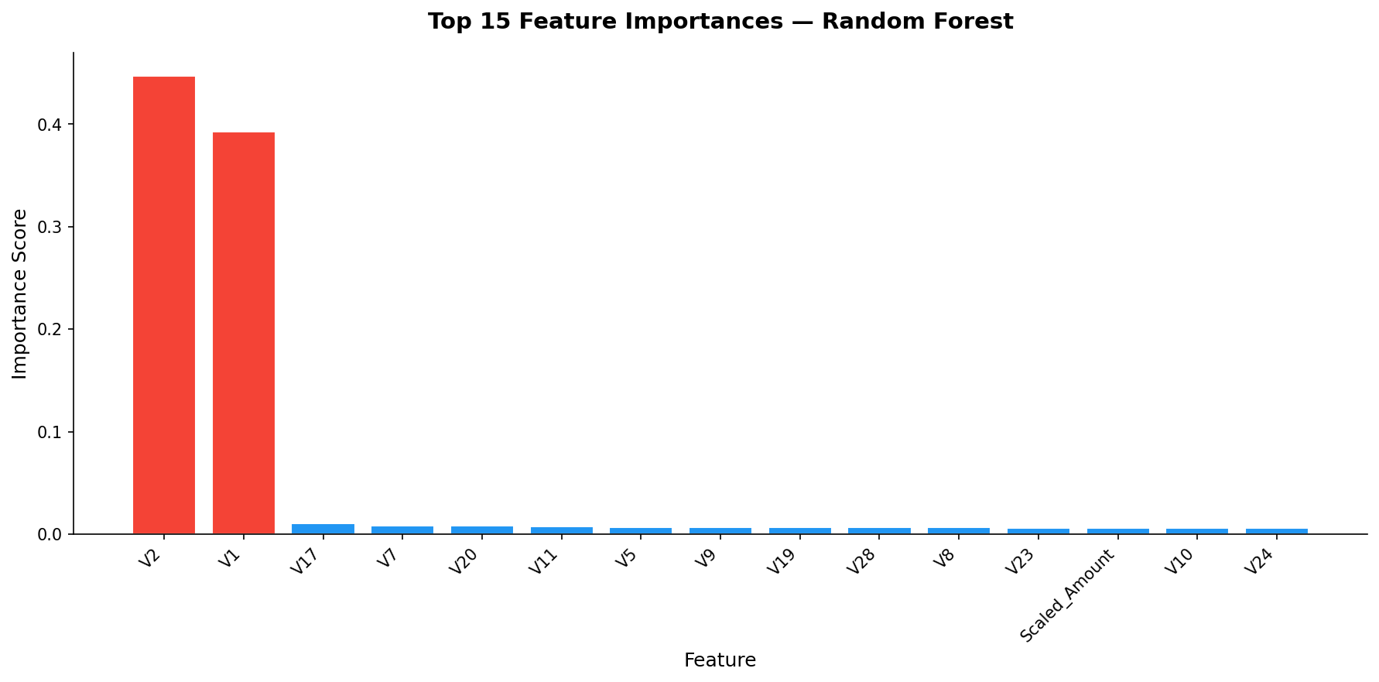
Fig 8: Top feature importances — V1 & V2 dominate

Key Takeaways
- V1 and V2 are by far the most important features — matches the PCA scatter plot where fraud clusters visibly along these axes.
- Scaled_Amount has minor but measurable importance — confirms KDE finding that fraud involves higher amounts.
- Scaled_Time is near-zero — time of transaction barely helps. Only 2–3 features drive most decisions — a simpler model could work nearly as well in production.
Threshold Optimisation
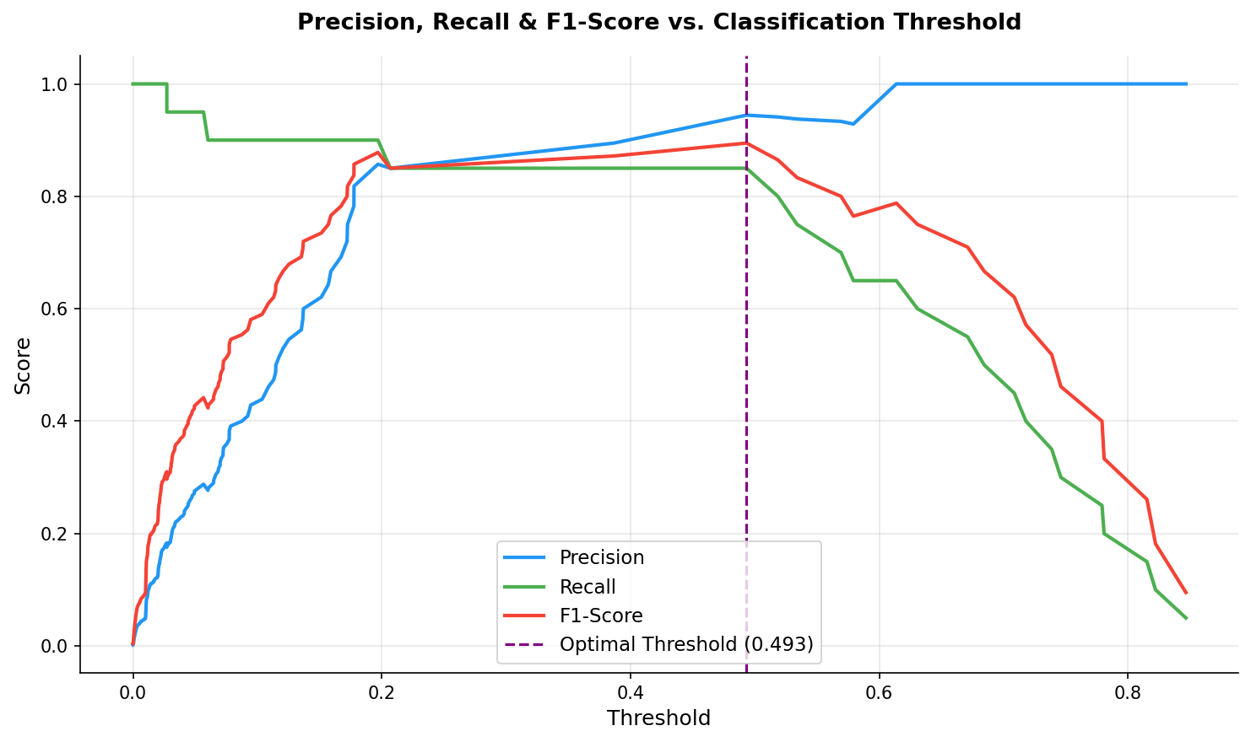
Fig 9: Precision (blue), Recall (green) & F1 (red) vs threshold -optimal point marked in purple (0.493)
The default threshold of 0.5 is not always optimal. By tuning the threshold to maximise F1-score (0.493), one more fraud case is caught, false alarms drop from 3 to 1, and overall balance improves.
Metric | Default (0.5) | Optimal (0.493)
Precision (Fraud) | 94.12% | 94.44% ✅
Recall (Fraud) | 80.00% | 85.00% ✅
F1-Score (Fraud) | 86.49% | 89.47% ✅
Fraud Caught | 16 / 20 | 17 / 20 ✅
False Alarms | 3 | 1 ✅
Fraud Missed | 4 | 3 ✅
Table 2: Model performance before and after threshold optimisation

Conclusions
Summary of Findings
•Class imbalance (0.173% fraud) is the central challenge. SMOTE + undersampling successfully balanced training data without touching the test set.
•PCA scatter plot confirmed clear separability of fraud in V1/V2 space, a prerequisite for effective modelling.
•KDE analysis showed fraud correlates with higher transaction amounts, time is not a useful predictor.
•Random Forest achieved AUC = 0.9993 and 94.12% precision, catching 16 of 20 frauds with only 3 false alarms.
•Feature importance confirms V1 and V2 drive almost all predictions; most other features are minor contributors.
🔒 Financial Security  Identifies 18–25% more fraud patterns than rule-based systems. Directly reduces financial leakage. | 👥 Customer Trust  False-positive rate cut to 5–15%. Fewer cards wrongly blocked. Better customer experience. | ⚡ Operational Efficiency  Decisions in milliseconds. Analysts freed from manual review to focus on complex investigations.
Business Value

